Home chronic Respiratory Failure &
Non-Invasive Ventilation Service

Contact Number: 07989 227375
Dr Simon Merritt: Lead consultant
Laura Harrup: NIV service lead Nurse
Penny Webster: senior physiotherapist
Email: esht.hmvs@nhs.net

Local chronic type 2 respiratory and NIV service.

The local home NIV service is a small team consisting of a consultant, nurse and physiotherapist. We offer support to patients with chronic type 2 respiratory failure, who have a GP within Hastings, Rother and Eastbourne, Hailsham, Seaford CCGs.
We cannot support complex patients such as those with spinal injuries, those who need a cough assist and those needing trachy ventilation.
We do not offer CPAP, this is provided by the sleep studies unit at the Conquest hospital.
NIV is usually offered to patients found to be in type 2 respiratory failure (T2RF). Indications for this are raised Co2, and normal/ low hCo3 in acute T2RF, and high in chronic T2RF on blood gases, and symptoms such as: Drowsiness, Confusion, Asterixis, Malar flush, Headaches, Shortness of breath.
Medical history is also an important part of assessment, as people with certain medical conditions are more likely to experience T2RF. These include those with: COPD, OSA/OHS, people with neuromuscular conditions such as MND.
To confirm this diagnosis an ABG MUST be undertaken.

Follow acute NIV protocols during admission, which can be found on the respiratory wards.
Patients requiring acute NIV are usually commenced on the respiratory wards or ITU. They can be commenced on acute NIV in A&E, but they must be transferred to Baird ward (Conquest), or Westham (EDGH) or ITU to continue this therapy.
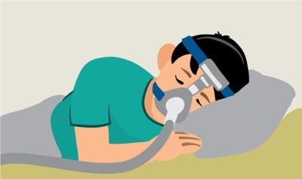

Referrals MUST be completed using the referral form on esearcher and sending this to: esht.hmvs@nhs.net

Verbal/ telephone/ emails with no referral/incomplete forms will not be accepted.

Follow home service NIV flow chart which is available on respiratory wards for discharge planning.
