Dear all Resident Doctors,

As part of the 10 Point Plan for Improving Working Lives of Resident Doctors, the study leave course reimbursement process is changing.

As of 1st April 2026, we will no longer only reimburse once proof of attendance is received, but it will be possible from the time of booking.
The end goal is that this is a centralized national process via an online portal.
However, this is still under development and in the interim we have devised a process internally, so our RDs are not missing out.

The initial phase of study leave approval remains the same – with the same form submission. However, it is the stage beyond this which has changed.
This document first outlines the new process for claiming followed by how to sign up and use the new system - the system can be accessed via this link / the link below on the document from any trust device.

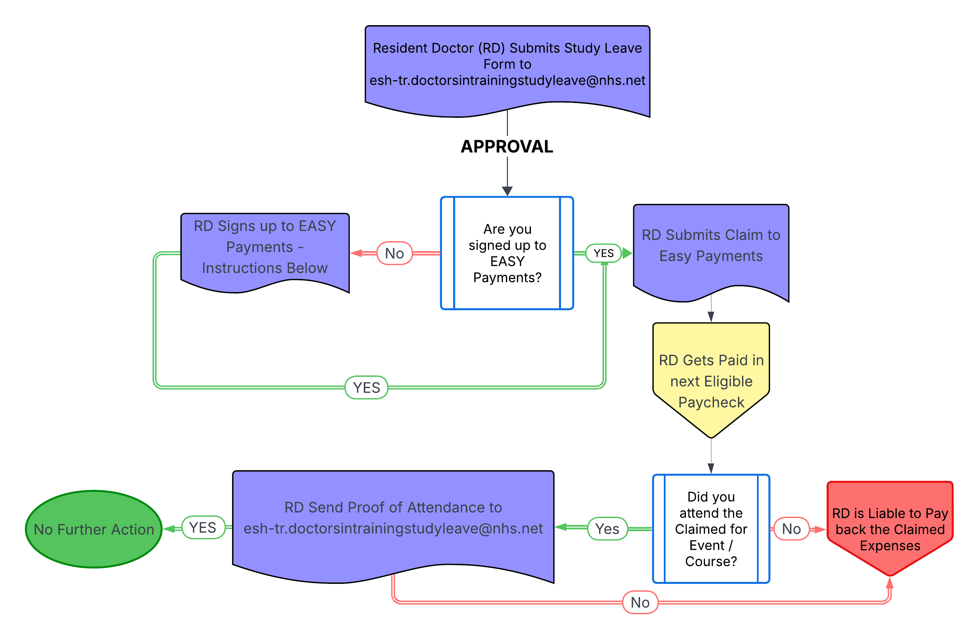

EASY – Staff Expenses User Guide

EASY Expenses was introduced in the Trust in July 2022 and is the Trust’s system for claiming staff expenses. All employees including medical staff, need to submit expense claims via the EASY system. The only exception will be for medical study leave.

The advantages of the EASY system are:
- It reduces duplication (manual forms must be written up, and then manually entered).
- It eliminates paper and the risk of claims getting lost in the post.
- It is easy to track which stage in the process the claim is at:
  - Unsubmitted
  - Submitted
  - Accepted (or rejected) and finally,
  - Extracted for payment.
Staff expenses are paid as part of your monthly salary.

There is a restriction within EASY that will prevent any claims beyond 92 days being submitted, this is to ensure that claims are submitted promptly.

Useful Information
The Trust’s webpage contains some useful tips (videos are being reviewed):
Travel claims and expenses - tasks and guides (esht.nhs.uk)

The system itself contains a lot of ‘how to’ guides, just search the ‘Help/Support’ section within the system (top right) and then the FAQ’s. Just type what you need help with, or key words and useful guides will be returned for you to view.

Once in the system, select this button:

Remember to read the messages on the home page message board, as this is where details about the deadlines for the next payment extract are displayed. Other useful system tips are also displayed here.
How to Register with EASY
Please make sure that you have added your NHS email address to your ESR record as this can stop you being able to register.
System Link: EASY | Login (giltbyte.com) - You will need to register by clicking on the link highlighted yellow as shown below:
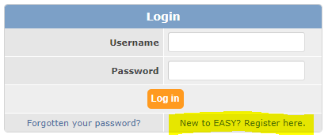

You will need a password to log in to the system and a smartphone to set up MFA to be able to submit and/or authorise expense claims and/or vehicle documents.

If you forget your login password, you can just select your ‘Forgotten your password?’ link on the login screen.

Please allow 24 hours after registering before trying to do anything in EASY as it is linked to ESR and will look up your assignment details, your home address, base location etc.
Submitting Expense Claims
To submit a claim, from the self-service menu on the left-hand side of the screen, and within the expenses sub-section, select ‘Expense Claims’.

In the ‘unsubmitted’ section, select ‘add/edit’. This screen displays in two halves, the top half is for ‘mileage claims,’ and the lower half is for ‘other claims.’

You will likely be using only – ‘Course/Study: Fees or Expenses’

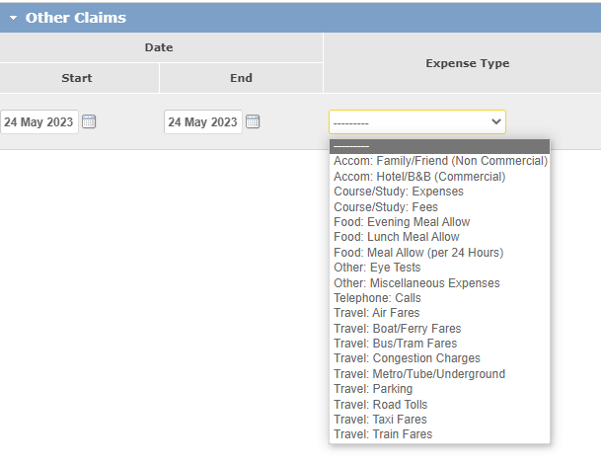
Once the ‘Expense Type’ has been selected, choose the ‘Reason’ for the expenses, from the drop-down menu.

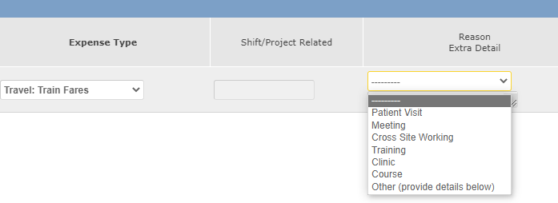

Then add the amount that is being claimed and upload your receipt by clicking on the new document icon to the left of the magnifying glass (noting you will have needed to save it on your computer somewhere beforehand).

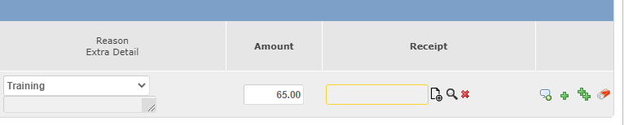

Clear this field.

Additional Information – when you select this icon a text box appears to enable you to provide additional information in support of your claim, e.g., certificate of attendance on the course or confirmation of booking etc.

Add Row – by selecting this icon a blank row is added above the current row to enable you to enter the details of a new journey.

Repeat Claim – by selecting this you can repeat the details of a claim.

Clear this row.

Save when complete and then submit. This action will then send an automatic email notification to your approver notifying them that they have an expense to claim.

08 – Checking Claim Status
When you have submitted claims, they will no longer appear in the ‘Unsubmitted Claims’ section and will instead appear in the ‘Submitted Claims’ section of the expenses screen.

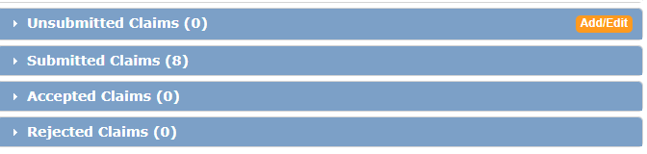
Claims in the ‘Submitted Claims’ section, are awaiting authorisation by an approver. Approvers are automatically sent an email when there is an expense claim to be authorised. Emails are triggered in the system when claims are submitted. In the example above, there are 8 claims awaiting approval.

Once claims are approved (or accepted) by an approver, the claims will move into the ‘Accepted Claims’ section and await the next payment extraction. Check the home page message board for details of when this is.

If claims are not approved by the approver, they will move to the ‘Rejected Claims’ section of the expenses screen. You will be notified if any claims are rejected because a rejection, automatically sends an email to the claimant explaining the reason given by the approver for rejecting the claims.
You will need to discuss with your line manager and resubmit if necessary.
09 – Claim Approvers
You can find out who can authorise you claim either in the ‘My Access’ section of the self-service menu, or within the ‘Submitted Claims’ section.

To check in the ‘Submitted Claims’ section, click on the ‘submitted’ line under the ‘Status’ heading.

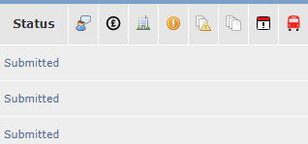

Clicking on this label will return a list of all approvers who can authorise the expense claim.

Alternatively, from the self-service menu on the left-hand side of the screen, click on ‘My Access’ and the last section labelled ‘Who can? my?’ is where you can view approvers.

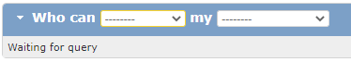

In the first drop down, select ‘Authorise’ and in the second drop-down, select either ‘Expense Claim’ or ‘Vehicle’.

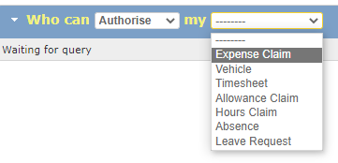

This will then return a list of approvers who can authorise your claims and/or vehicle documents.

14 – Adding your device
Before You Start
You must have downloaded the app to your mobile device before you follow the steps below. At this stage, it is also recommended that you log into EASY as you will need go to a page in EASY as part of the registration process.

Steps to Follow
When the app first opens you will have 2 options to choose from on the screen; Read QR Code and Register Manually. We will cover each of these options in turn below.

Reading QR Code
1. Tap the Read QR Code button

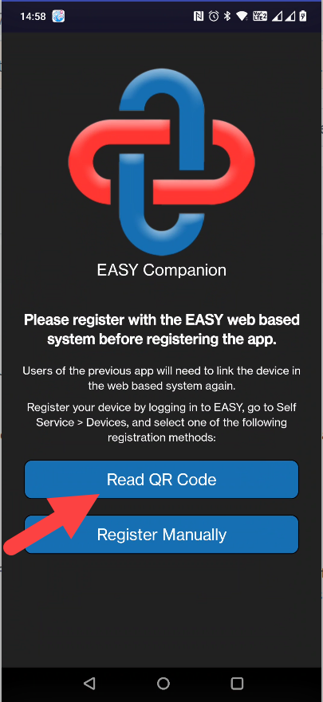

2. You will now see a message asking you to allow the app to take pictures and record video. You should tap the While using the app option.
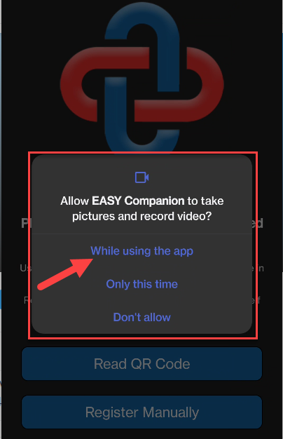

3. Now go to EASY, and log in if you have not already done so, and click on the Devices option in the Self Service menu.
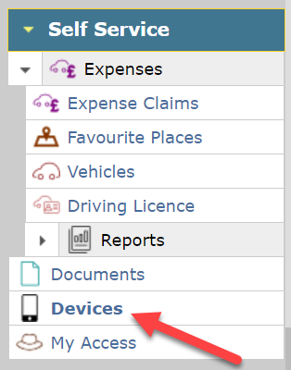

4. Using your mobile device, scan the QR code that is on the Devices page. Please note the QR code on the Devices page only applies to you.
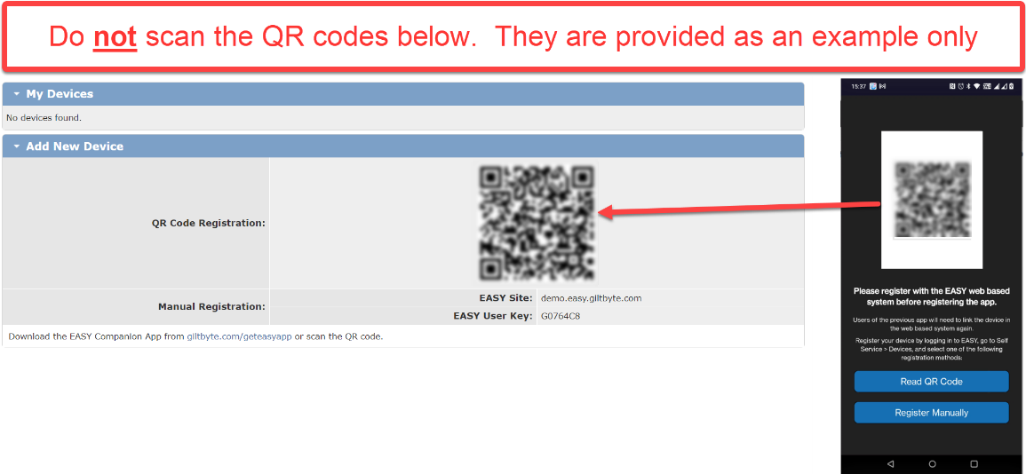
5. On your mobile device the app will confirm that the registration data has been received.
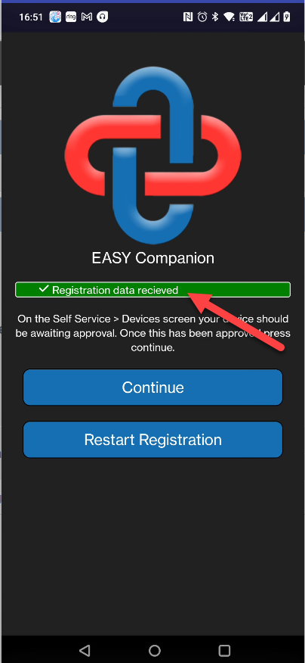

6. On the Devices page in EASY, your mobile device will show in the My Devices section. Click on the Approve button to add the device for use with your EASY user account.
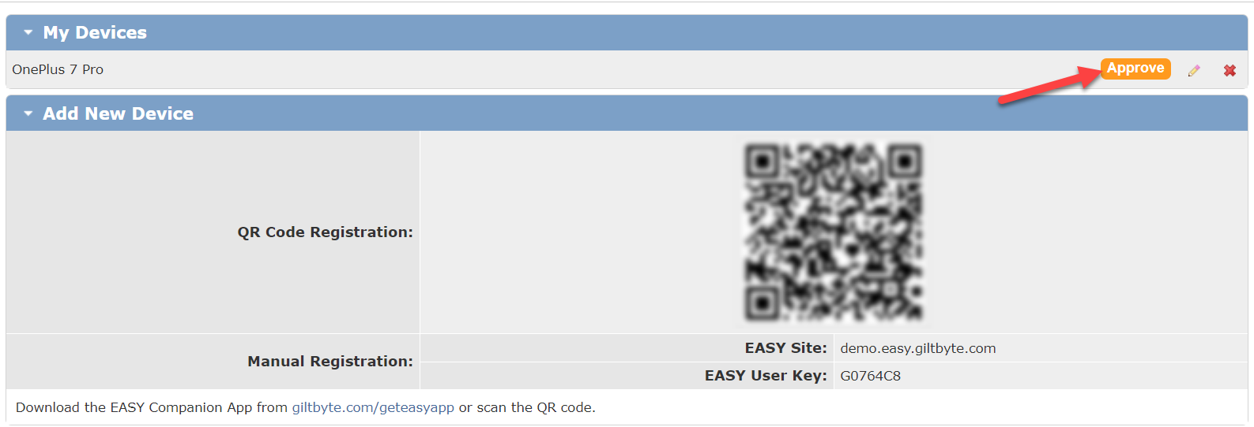

7. You will now see a request to approve your mobile device by providing your TOTP (Time-based One Time Password) code. After entering the requested TOTP code, click on the Approve button.

8. You will get a message confirming that your mobile device has been approved, and the Approve button has disappeared.

9. After you have approved your mobile device, you should then see the app Home page. There may be a short delay before the Home page will appear, or you can click on the Continue button to move things along.
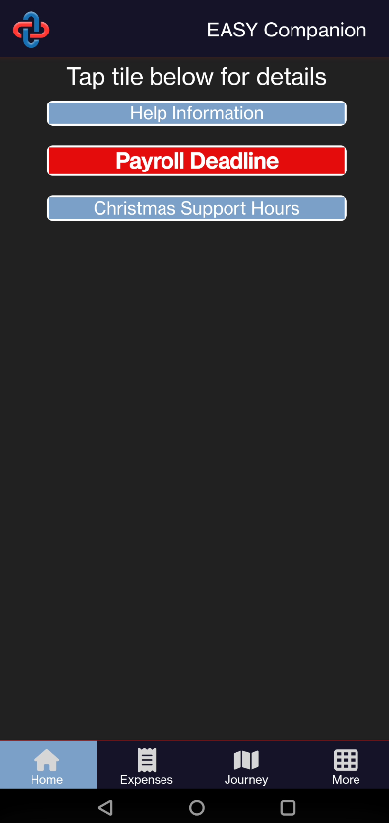

You can now use the app to enter your expense claims and upload documents to link vehicles.

ICONS
Add Row – by selecting this icon a blank row is added above the current row to enable you to enter the details of a new journey.

Repeat Claim – by selecting this you can repeat the details of a claim.

Additional Information – when you select this icon a text box appears to enable you to provide additional information in support of your claim, e.g., the additional mileage claimed may be the result of a road closure, or details of the passenger(s) being claimed for.

Continue Journey – using this icon pre-fills a new row with most of the values from the current row so that it can be used as a continuation of the current journey, e.g., where you are returning to base or travelling on to another location.

View Map – selecting this icon will obtain the journey’s route using Google Maps.

Return Journey – selecting this icon completes a new row with the return journey details.

Clear this row.

Icon is used to indicate that you have provided additional information in support of this claim.

Calendar

IMPORTANT REMINDERS
- Deadlines are displayed on the home page message board.
Individual claims cannot be extracted in isolation, therefore if deadlines are missed, claims will not be extracted until the following month and no advance will be made against the outstanding claim.

- Useful tips and reminders are also displayed on the home page message board.
Be sure to check this page regularly.

- Allow sufficient time for approvers to approve your claims or documents. Submit claims monthly and in advance of the deadline.

- Remember there is a 92-day cut-off built into the system. Claims submitted outside of this window will automatically be rejected.

- If you need to email the Staff Expenses Team, remember to include your assignment number, and put a description of the issue in the email subject bar.

Staff Expenses Team.
esh-tr.staffexpenses@nhs.net

